Cultural Tour of Quito (full-day): includes guide, professional driver, and lunch at a local restaurant (private)
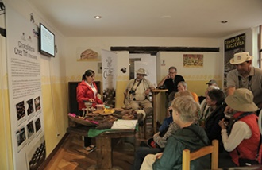 | 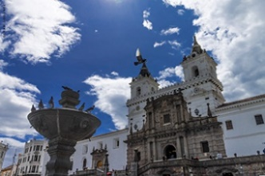 | 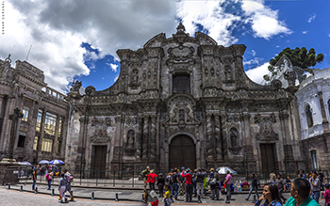
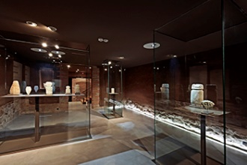 | 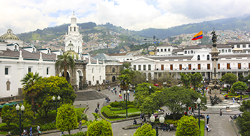 | 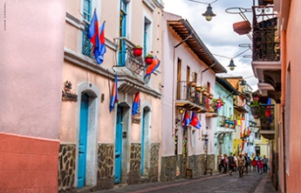
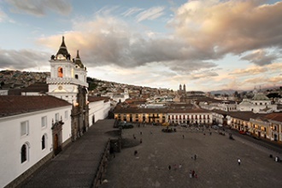 | 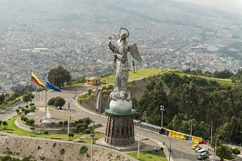 | 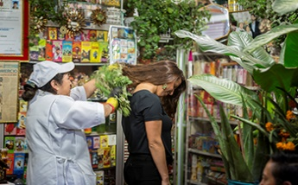
This full-day tour allows you to experience Quito like a local.
On this day, we visit the Casa del Alabado Museum, a delightful spot, situated at the edge of the iconic San Francisco Plaza. The museum occupies one of the oldest houses in the Historic Center and features a privileged look at pre-Colombian art, focused on the religious practices of each group.
We also visit La Compañía Church (also known as the Church of the Society of Jesus), considered the crown jewel of Quito’s Historic Center and one of the most important examples of Baroque architecture in the world. This masterpiece is the product of a European vision realized through the in situ work of creative and talented artisans in the artistic tradition of the Quiteño School.
The ornate San Francisco Church and Convent, marking the arrival of the first Catholic order in Quito, is considered “America’s Escorial”, built on top of a centuries-old pre-Incan settlement. The church, which features a majestic choral area and a gorgeous crown-like dome, also features the “Winged Virgin” above the main altar. It is a perfect example of Renaissance, Mudéjar, and Baroque Quiteño styles. The interior courtyards and convent are a perfect complement to the visit. This site serves as the inspiration for the Legend of Cantuña, which tells the story of a cunning indigenous worker that managed to deceive the Devil. The imposing façade of the church and convent is as impressive as its grandiose steps, which land upon San Francisco Plaza, where we enjoy a light snack at the Tianguez (restaurant) while learning about this place –one of the most iconic urban settings in the country’s capital. The plaza occupies the same space where once there stood an indigenous marketplace.
Chocolatería Chez Tiff was founded by an Ecuadorian-Swiss couple whose talent for making delicious chocolate from the finest Ecuadorian cacao is shared with visitors from all over during this uniquely interesting tasting.
Independence Square (also known as the Plaza Grande) is at once, a hub for city planning and development and a nexus for Ecuadorian society, given that the Presidential Palace (Carondelet), the Archbishop's Palace, the Cathedral of Quito, and the city’s Municipal Offices are all located around it. Standing tall at the center of the square is a monument that honors the nation’s colonial independence, constructed out of marble and bronze in 1906.
Popular amongst Quiteños and foreigners alike, a stroll along Calle La Ronda, -a narrow street in the Mediterranean-Andalusian style, with balconies, serenades, and traditional artisan workshops– is an exploration of the city’s rich history and tradition. All types of artists and political figures have walked along the streets of this iconic neighborhood, which is full of cultural, artful, and culinary spots.
The tour also includes a visit to Panecillo Hill, practically in the center of Modern-day Quito. This scenic viewpoint rises to a height of approximately 9,950 ft (about 3,000 m) above sea level and offers beautiful, panoramic views of the city. The 147 ft (45 m) Virgin of Quito is an aluminum statue built in 1976 by Spanish artist Agustín de la Herrán Matorral that sits atop the hill.
Our tour would not be complete without a visit to the San Roque Community where we learn about their educational and touristic project, Caminos de San Roque, which involves the community and was awarded First Place as part of Casa América Catalunya’s 2010 Cultural Cooperation for Development Project. Their efforts to rescue the area’s intangible heritage is noted in their exploration of life, beliefs, gastronomy, and ancient quiteño traditions. We meet with the neighbors and medicinal healers, and acquaint ourselves with the inhabitants’ many impressive artisanal skills.
Recommendations
• Dress in layers and bring a sweater or jacket.
• Wear comfortable walking shoes.
• Bring a hat, sunglasses, and sun protection (SPF 40+).
• Great photo opportunities, don’t forget to bring a camera
• Depending on the weather, bring a raincoat or umbrella.
Notes
• This tour is offered daily and lasts approximately 9 hours. Access to the San Roque Community is closed on Sundays; instead we recommend you review other options with your destination expert, for example: a visit to the neo-gothic Basílica of the National Vow or the historical Alberto Mena Caamaño Wax Museum.
• Tour involves walking at altitude
• The order of visits may vary, depending on weather conditions and day of the week.
Included: Private guide and driver, lunch, and all entrance fees.
Not included: Tips, beverages not mentioned, personal expenses.

